Group Number/Tutorial Slot: Group 13
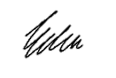
Group Members & Matric No(s): Signatures:
Eden Ester Emaritus (109675)
Rachel Marvin Wan (81010)
Subject Code: TMF1414 | Subject Name: Introduction To Programming

Assignment/Project: | Assignment: UNIMAS PRIMA Outpatient Clinic Billing System

Name of Lecturer: | Dr. Irwandi Hipni bin Mohamad Hipiny

Due Date: 1st December 2025 | Date Submitted: 30th November 2025

All work must be submitted by the due date. If an extension of work is granted, an assignment extension acknowledgement slip must be signed by the lecturer/tutor and attached to assignment.

Please note that is your responsibility to retain copies of your assignment.

Plagiarism and Collusion are methods of cheating that falls under Peraturan Akademik Universiti Malaysia Sarawak para 11: Etika Akademik

Plagiarism
Plagiarism is the presentation of work which has been copied in whole or in part from another person’s work, or from any other source such as the internet, published books or periodicals without due acknowledgement given in the text.

Collusion
Collusion is the presentation of work that is the result in whole or in part of unauthorized collaboration with another person or persons.

Where there are reasonable grounds for believing that cheating has occurred, the only action that may be taken when plagiarism or collusion is detected is for the staff member not to mark the item of work and to report or refer the matter to the Dean. This may result in work being disallowed and given a fail grade or if the circumstances warrant, the matter may be referred to a Committee of inquiry for investigation. Such investigation may result in the matter being referred to the University Discipline Committee, which has the power to exclude a student.

MARK :

Table of Contents

Introduction 2
Pseudocode 3
Flowchart 4-5
Sample Run of Program 6
Proof of Discussion 6

Introduction
This purpose of this assignment is to create a billing system for UNIMAS PRIMA Outpatient Clinic. The system must be able to calculate the total medical charges for each patient based on their consultation type, medication cost and display the per patient bill details. The system also must allow repetition for multiple patients and show the overall summary of the day which includes number of patients, total medication cost and total collected revenue.
Through this assignment, we need to understand and meet the requirements needed, design the program flow using proper control structures and input validation, and build a working solution using C programming. The program must be organised, readable and produce the correct and clear output. Overall, this assignment strengthens our skills in problem-solving especially in learning on how to turn a real-life situation problem into a working program.

Pseudocode

- START
- DECLARATION OF VARIABLES
//For billing
char patientName[50], c, int consultType, float consultFee = 0.00, medCost, totalFee = 0.00, serviceCharge = 0.00
//For daily summary
int totalPatients = 0, float totalmedCost = 0.00, totalRevenue = 0.00
//For input validation
int ch

- LOOP STATEMENT BODY (post-test loop: do-while)
Do
//Reset values for each next patient
consultFee = 0, serviceCharge = 0
  - READ INPUT
//Input patient name
//Input consultation type (with validation, while: pre-test loop)
//Input medication cost (with validation, while: pre-test loop)
  - SELECTION STATEMENT (switch)
switch (consultType)
case 1: consultFee = 10.00
case 2: consultFee = 45.00
case 3: consultFee = 30.00
  - SELECTION STATEMENT (if-else if ladder)
if (medCost<=50){
serviceCharge = 0.00;
} else if (medCost<=99.99){
serviceCharge = 5.00;
} else {
serviceCharge = 10.00;
}
//Calculate total fee
totalFee = consultFee + medCost + serviceCharge
//Update daily summary
totalPatients++, totalMedcost += medCost, totalRevenue += totalFee
//Display bill for each patient
//Sentinel check ask to continue (with validation, while: pre-test loop)
} while (c !='N' && c !='n');
- DISPLAY (daily summary)
- STOP

Flowchart
START

DECLARING VARIABLES
patientName, consultType, consultFee, medCost, totalFee, totalPatients, totalMedcost, totalRevenue, serviceCharge, c, ch

RESET VALUE
consultFee = 0, serviceCharge = 0

READ
patientName

READ
consultType
False
True
Invalid! Please enter positive value only
while (medCost<0 || scanf("%f", &medCost) != 1)
2
Invalid! Please enter 1, 2 or 3 only
while (consultType<1||consultType>3)
False
True
READ
medCost
1
END
DISPLAY DAILY SUMMARY
Total patients, Total medication cost, Total revenue
Case 3:
consultType=3
False
True
False
True
while (c!='N' && c!='n' && c!='Y' && c!='y')
True
break
consultFee=10
True
False
False
break
consultFee=45
Case 1:
consultType=1
Case 2:
consultType=2
switch (consultType)
True
break
consultFee=30
READ
medCost
serviceCharge=0
True
False
medCost<=50
True
serviceCharge=5
medCost<=99.99
False
serviceCharge=10
READ
c
DISPLAY BILL
Patient name, Service charge (RM), Total fee (RM)
CALCULATE
totalFee=consultFee + serviceCharge + medCost, totalPatients++, totalMedcost+=medCost, totalRevenue+=totalFee
while
(c !='N' && c !='n')
Invalid input! Please enter Y/N only!

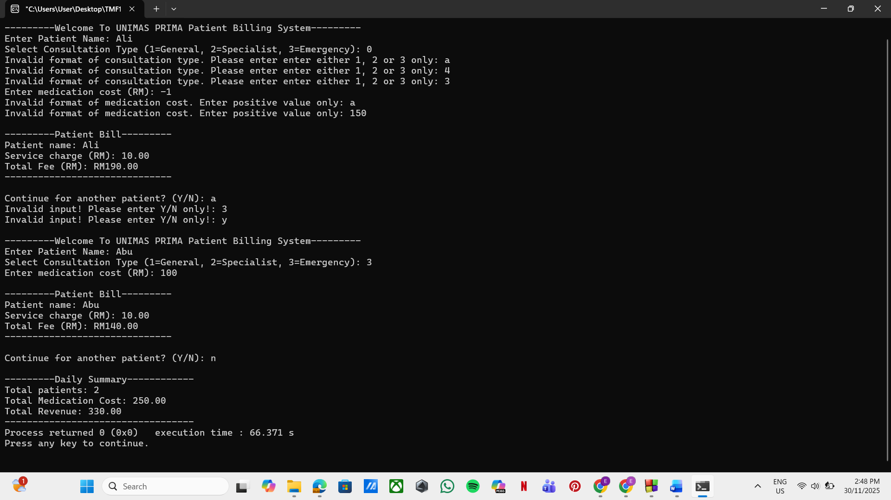
Sample Run of Program

- The code run validation test on consultation type, medication cost and the sentinel (Y/N) to ensure the user only enter the correct input format.
- The code displays each bill per patient after the user enter all the details.
- Daily summary is displayed at the end after the looping stop when user enter sentinel ‘N’ or ‘n’.

Proof of Discussion
